Exercise L10 Clustering using K-Mean
- Given X.csv, you follow the suite of K-mean clustering.ipynb to find optimal number of cluster (optimal K) based on Elbow or Knee plot. Print all the RSS (called .inertia_ ) that are appended into the variable Sum_of_squared_distances.
- Add the following module of KneeLocator to automatically finding optimal K, cross check the optimal K you obtain manually in (1). Select the best one, if not equal, and provide your opinion.
from kneed import KneeLocator
knee_locator = KneeLocator(K, Sum_of_squared_distances, curve="convex", direction="decreasing")
optimal_k = knee_locator.elbow

- Adapt the next cell to get optimal_k from (2) to get finalized version of clusters, then (i) print all the clusters’ centroid and (ii) print class numbers of all 500 data points.
- Use the AI of Colab to generate Scatter plot of all data points with coloring for each clusters. Ensure it looks similar to the below plot:
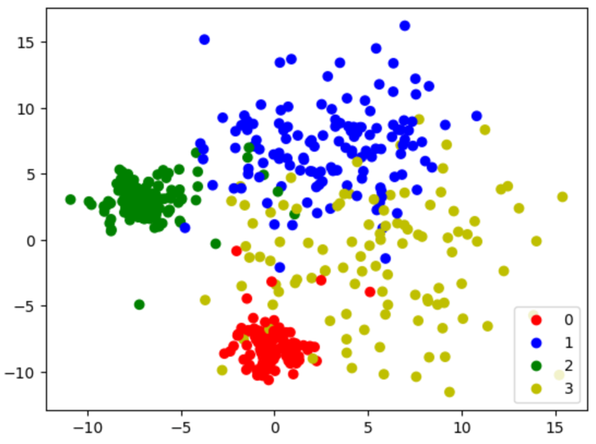
- Reading the given test file “cluster_representatvies.csv” and load it to the work space:
# Load the cluster representatives from the CSV file
cluster_representatives_df = pd.read_csv('cluster_representatives.csv')
cluster_representatives = cluster_representatives_df.values

- Then, using the cluster.predict() function to determine class for each of the data point in the test file. Print the outcome of prediction.
predict = cluster.predict(cluster_representatives)

